NATADS Activity Guide
  - Public Awareness Activity Entry
This guide will serve to provide specific instructions on how to enter Public Awareness Activities into NATADS.

To add a Public Awareness Activity into NATADS:

Sign in to NATADS (https://security.state572data.net/admin/Login) (Figure 1):
  - Username: Your Work Email
  - Password: This was a password of your choice, if you cannot recall, you can reset your password using your associated email address. Or contact me at: Kathrine@CFILC.org for one-on-one assistance.
Figure 1

On the next screen, “Home Page”, select the button titled “Day to Day (New)” (Figure 2)
Figure 2

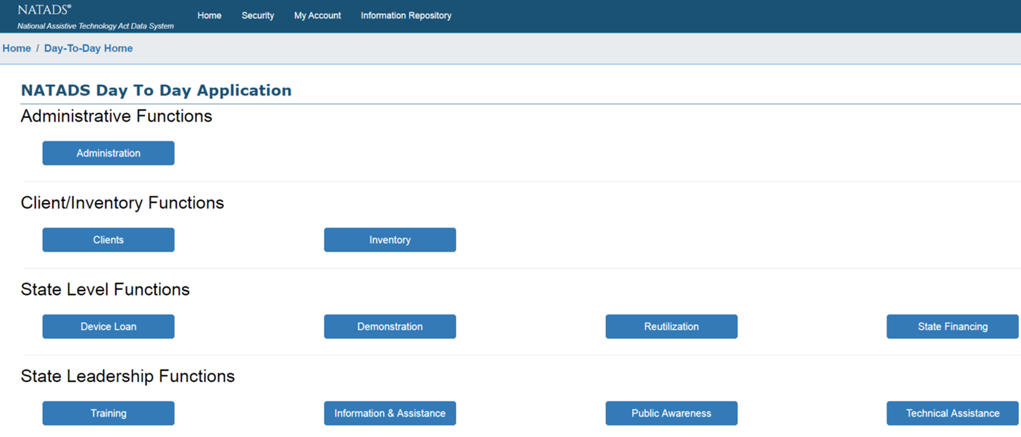
On the next screen, “Day to Day Application”, under the banner “State Leadership Functions”, select the button “Public Awareness” (Figure 3)
Figure 3

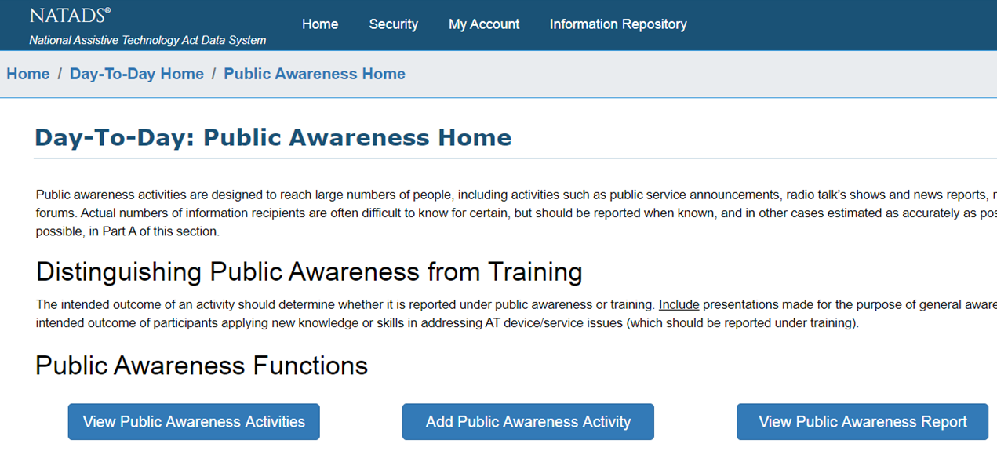
On the next screen, “Public Awareness Home”, under the banner titled “Public Awareness Functions”, select the button “Add Public Awareness Activity” (Figure 4)

Figure 4

On the next screen, “Public Awareness Entry”, under the banner titled “Date and User”, enter the following information (Figure 5):
  - “Date” – this field will automatically populate with the current date, so you must modify the date to match the date which the Public Awareness activity you are entering occurred
  - “Entered By” – this field will automatically generate the name of the person signed into NATADS, based on the login information used to enter the database, and cannot be altered. For this reason, it is important to always use your personal account, so the data can be validated
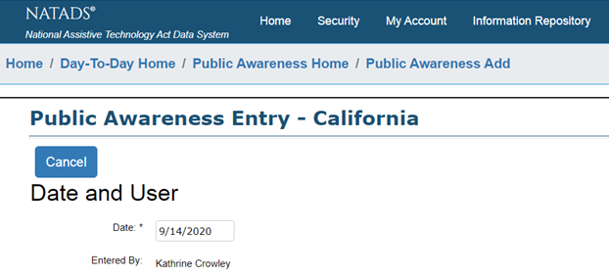
Figure 5

Continuing down the same screen, under the “Narrative” Banner there will be a text box with a 10,000 character count limit. Enter the following information (Figure 6):
  - Date and Time Range – month/day/year-month/day/year, from Xam-Zpm
  - Location – name of venue and address of venue
  - Medium – telecommunication, online, webinar, in- person, etc.
  - Type – tabling at expo, tabling at fair, radio interview, etc.
  - Staff involved – first and last name, title, and organization
  - Name and purpose of event – what content do you provide that was relevant to the purpose of the event
  - Describe activity – was it innovative or high impact, number of tables, types of interactions with participants (events such as these can facilitate opportunities to participate in device demonstrations and trainings alongside the public awareness activity itself) and any other details of note.
  - Estimate of participants and their potential demographic categories – rural, urban, educators, self-advocates, etc.
  - Materials and reuse items disseminated – type and amount
  - Be sure to outline any potential positive outcomes – educator learning about services for their students, consumer learning about a service and saying they will now seek out, etc.

Select the “Save” button underneath the left corner of the “Narrative” text box to complete entry of your Public Awareness Activity

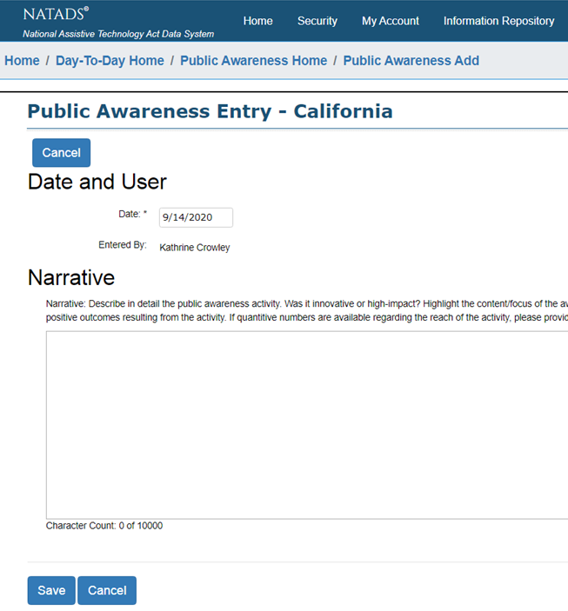
Figure 6

You have now completed entry of your Public Awareness Activity!

